**Karmayogi Polytechnic College, Shelve**

**Department of Computer Technology**

**Capstone-Project Report**

**Capstone Project (22060)**



**“Smart Attendance System”**

**Guided by:**

**Prof. Ghalame S. S**

**Presented By:**

**1. Mst. Bagal Rohit Ravindrakumar (CM 312)**

**2. Mst. Rokade Rohan Shivaji (CM 328)**

**3. Mst. Lokare Prajval Dattatray (CM 337)**

**4. Mst. Pawar Sachin Namdev (CM 352)**

During Academic Year **2020-21**

**Title of Capstone-Project:**

Smart Attendance System

1.0 Brief Description:

Smart attendance system software is a python 3.6 PyQt5 based software for colleges/organizations to know what attendance of which student in college these are clearly known in this software we will get the information about the attendance student wise of that college which is helpful for the faculty. We also added information of the clock in and clock out time of student. We’ve also shown a square on screen to show if the face of the student is recognized or not and name of that student under the square. We have proposed this software in English language. This project mainly deals with the design and implementation of python software with the help of python 3.6.0 on VS code platform “SMART ATTENDANCE SYSTEM" which is used for attendance related information, which is helpful for the faculty and college/organization.

The highlighted features of this project includes:-

* Identify real-time face of student.
* Collect information of particular student in colleges.
* Software design implementation.
* The main objective is to design the python software which gives the all about information of attendance of student.
* The computer system is used to see the implementation by using VS code software.
* Python 3.6.0, PyQt5 & XML are used for develop a software.
* This paper describes an application of the presented project which is based on the python3.6.0 platform.

2.0 Aim of Micro Project:

1. To provide all related information about the attendance of the students.

2. To provide clock in and clock out time of the students.

3. To provide attendance related information about particular student to faculty of the college.

4. To reduce the manual work.

3.0 Actual Resources Used:

|  |  |  |  |  |
| --- | --- | --- | --- | --- |
| **Sr. No** | **Name of Resource/material** | **Specifications** | **Quantity** | **Remarks** |
| **1** | Computer System | Computer (i3-i5 preferable RAM>2GB) | 1 | - |
| **2** | Operating System | Windows/Linux | 1 | - |
| **3** | Development Software | Python IDE | 1 | - |

4.0 Actual Procedure Followed:

|  |  |  |
| --- | --- | --- |
| **Sr.No.** | **Details of Activity** | **Name of responsible Team members** |
| 1 | Identify the problem | Mst. Bagal Rohit Ravindrakumar & Mst. Pawar Sachin Namdev |
| 2 | Preparation of capstone project synopsis | Mst. Lokare Prajval Dattatray |
| 3 | Collect relevant data /literature review | Mst. Lokare Prajval Dattatray |
| 4 | Analysis of data | Mst. Pawar Sachin Namdev & Mst. Rokade Rohan Shivaji |
| 5 | Prototype /Model | Mst. Rokade Rohan Shivaji |
| 6 | Report preparation | Mst. Pawar Sachin Namdev & Mst. Lokare Prajval Dattatray |
| 7 | Presentation of capstone project | Mst. Bagal Rohit Ravindrakumar & Mst. Lokare Prajval Dattatray |
| 8 | Preparation of SRS | Mst. Rokade Rohan Shivaji, Mst. Lokare Prajval Dattatray, Mst. Pawar Sachin Namdev |
| 9 | Preparation of PPT | Mst. Bagal Rohit Ravindrakumar |
| 10 | Development of project | Mst. Bagal Rohit Ravindrakumar & Mst. Rokade Rohan Shivaji |

5.0 Data flow diagram:

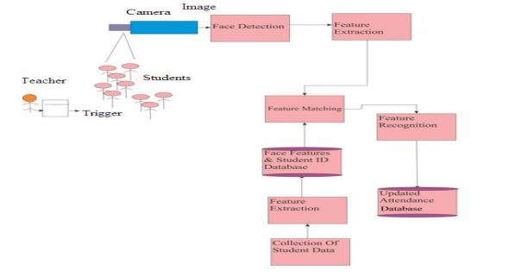

Figure Data flow Diagram

6.0 Class diagram:

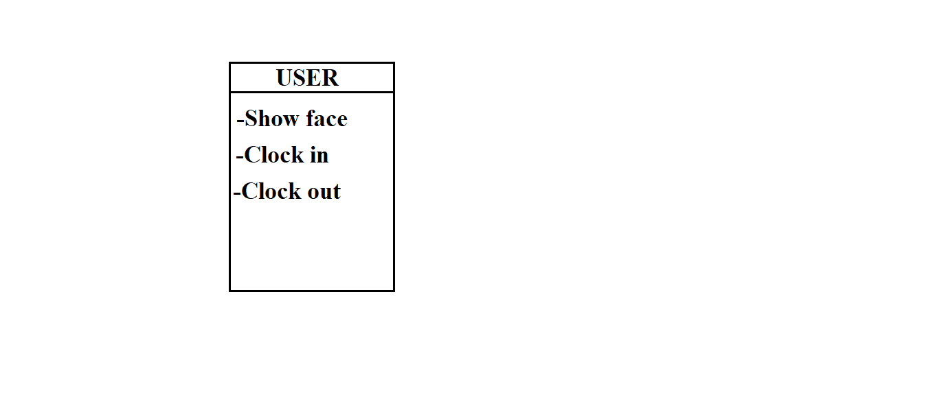

Figure Class Diagram

7.0 Use case Diagram:

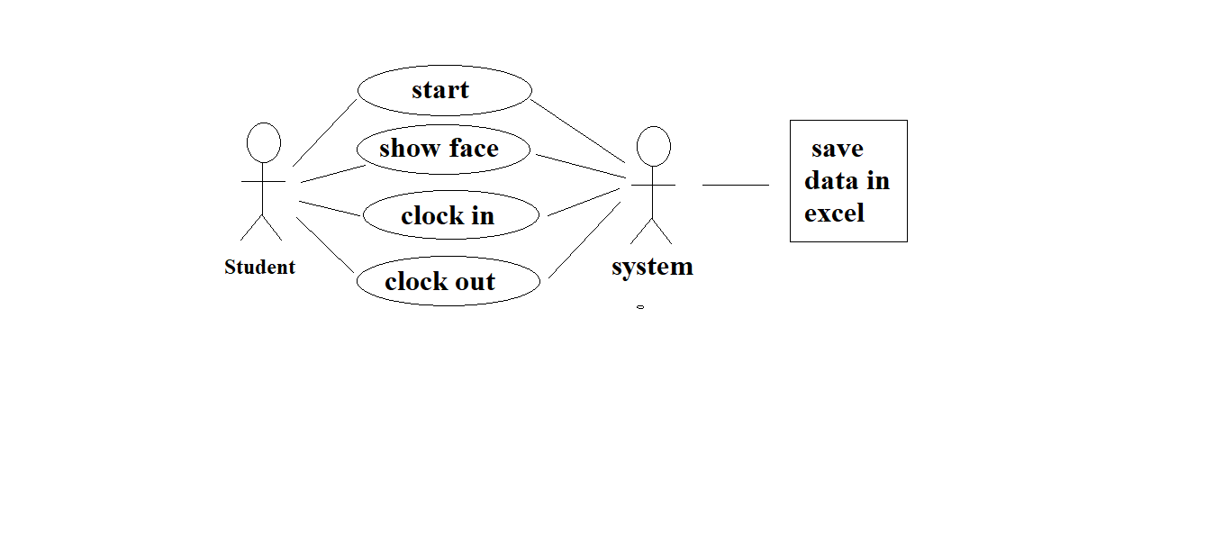

Figure Use Case Diagram

8.0 Sequence Diagram:

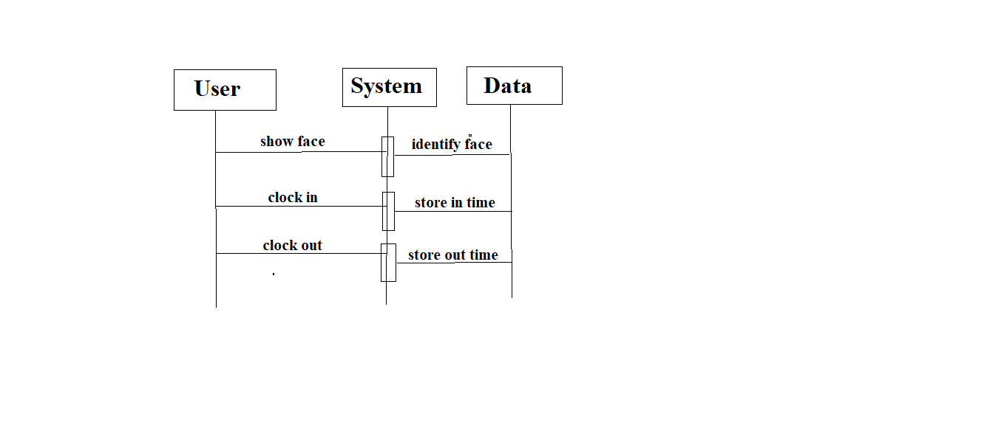

Figure Sequence Diagram

9.0 ER Diagram:

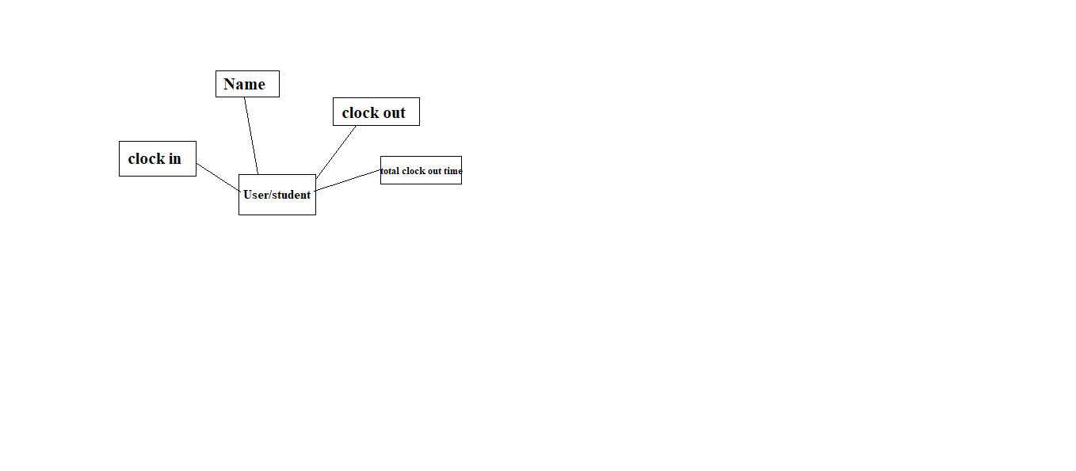

Figure ER Diagram

10.0 Outputs of the Micro-projects:

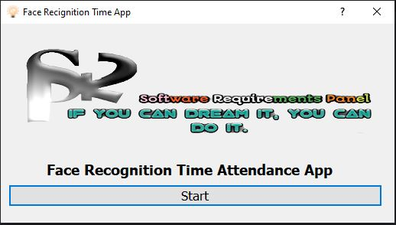

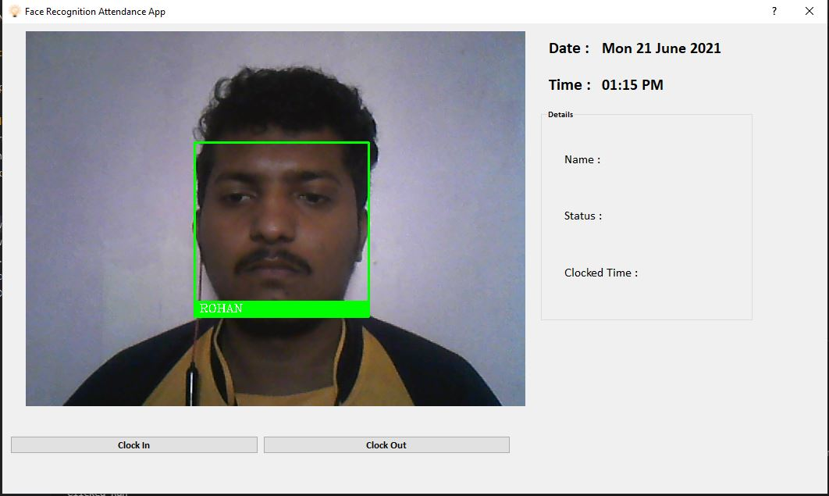

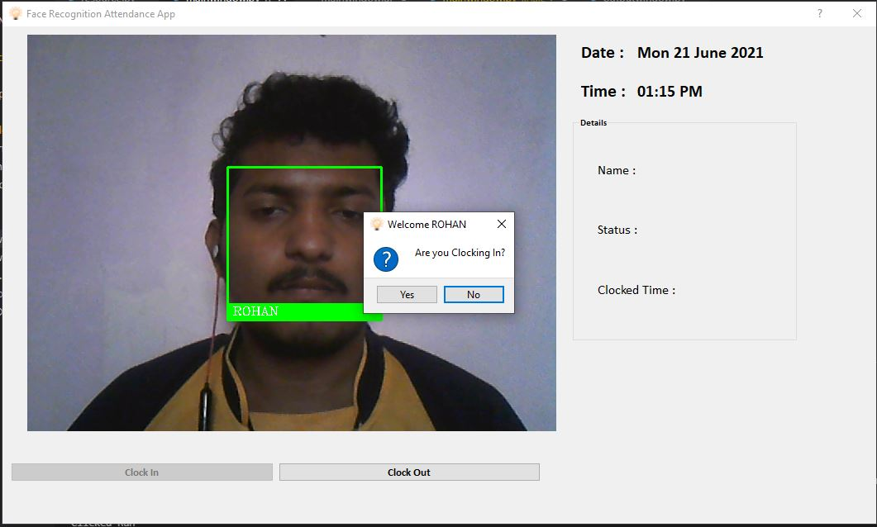

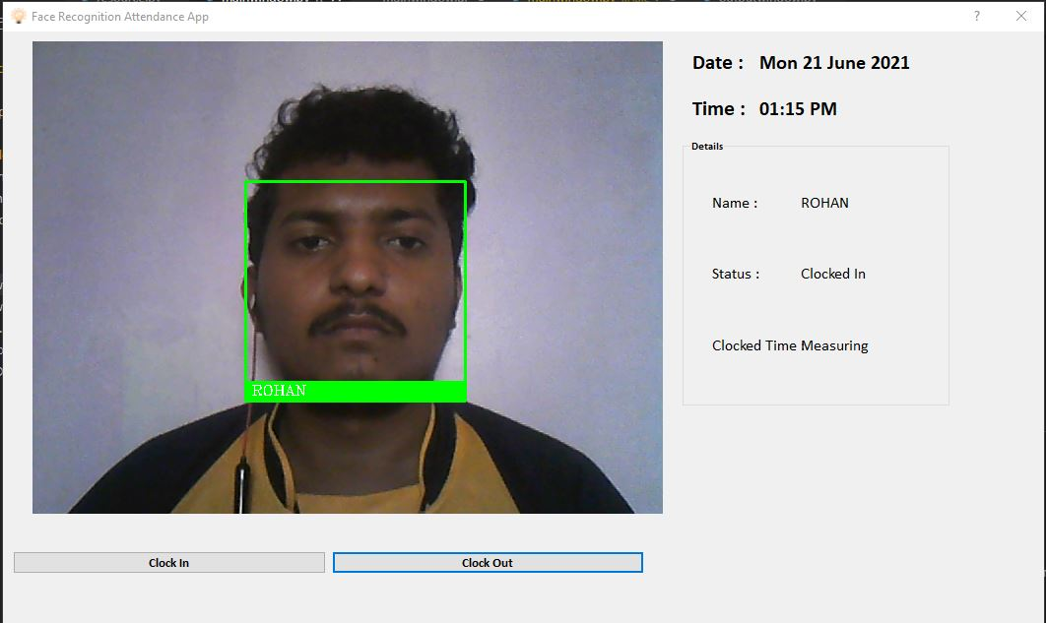

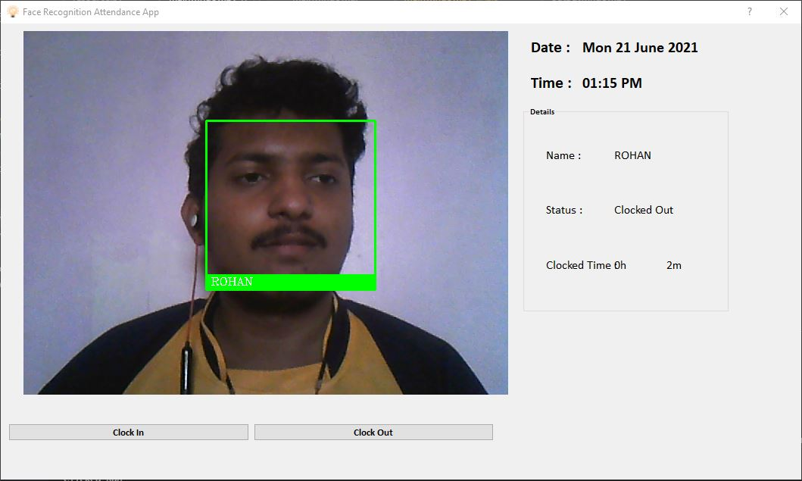

7.0 Skill Developed/ learning out of this Micro-Project:

* Through this project we’ve learnt what is dlib, what it does, how it works.
* We learnt about face-recognition, what it does, how it works.
* We learnt about PyQT5, what it does, how it works.
* We learnt about QtDesigner, what it does, how it works.
* We learnt how to use VS code for coding as a platform.
* We learnt about OpenCV, what it does, how it works.
* We learnt some more python pip commands.
* We also developed skill for logo and icon designing.
* We learnt how to import various packages and modules and use it in proper way.
* We learnt how to use excel for storing data.
* We learnt to use QtDesigner for designing GUI.